
Department of CSE

B.Tech. CSE Trimester -5

Roll Number : 2520030299
Name : Shaila banu

Cloud Infrastructure and Services
25CS2206E

LAB RECORD
2026

Experiment -1.2

AIM: To create an Zero-Budget-FreeTier.

Description:
An AWS account provides access to the AWS Management Console, where cloud resources can be created and managed. A monthly cost budget was configured to monitor spending across AWS services and send an email alert when actual costs exceed $0. The budget amount is set to $1.00 because AWS does not accept a zero-dollar budget. A budget alert helps monitor costs but does not stop resources or prevent charges.

Steps:
1. Sign in to the AWS Management Console.
2. Open “Billing and Cost Management” and select “Budgets”.
3. Choose “Create a budget, then select “Customize (advanced)” and “Cost budget”.
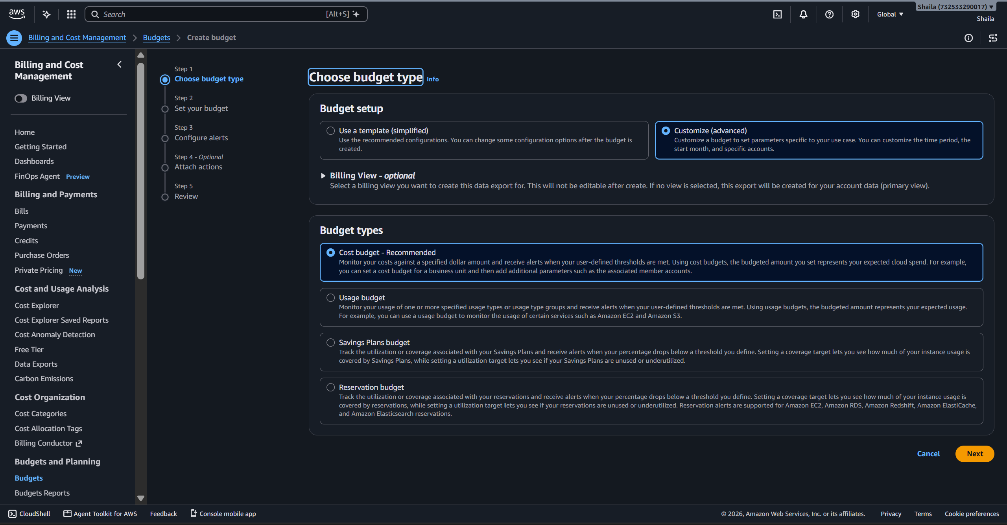

4. Enter the budget name “Zero-Budget-FreeTier*”.
5. Set the period to Monthly, renewal to “Recurring”, and start month to the current month.
6. Set the budget amount to $1.00 and keep the scope as “All AWS services”.
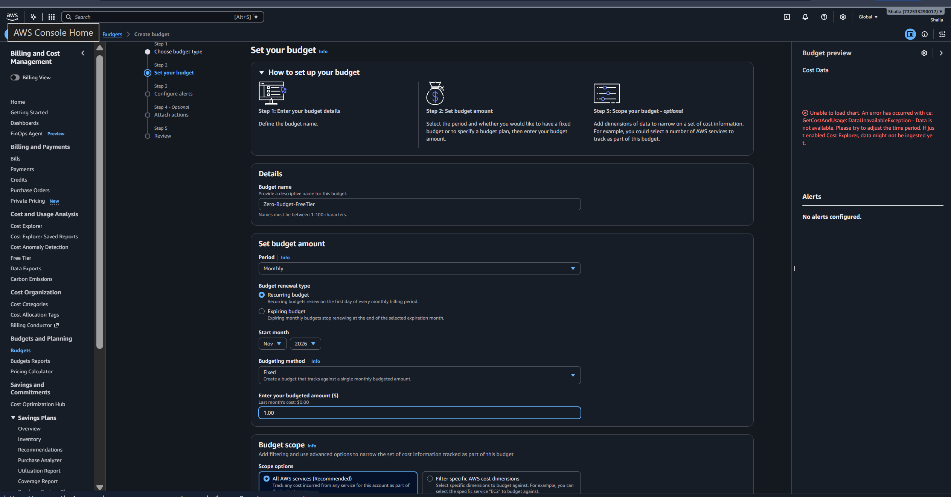

7. Add an alert threshold of $0.00, measured against “Actual costs”.
8. Enter an email address for notifications and leave optional actions unconfigured.
9. Review the settings and create the budget.
10. Verify that the budget appears in the Budgets list and confirm the alert email if AWS requests verification.



